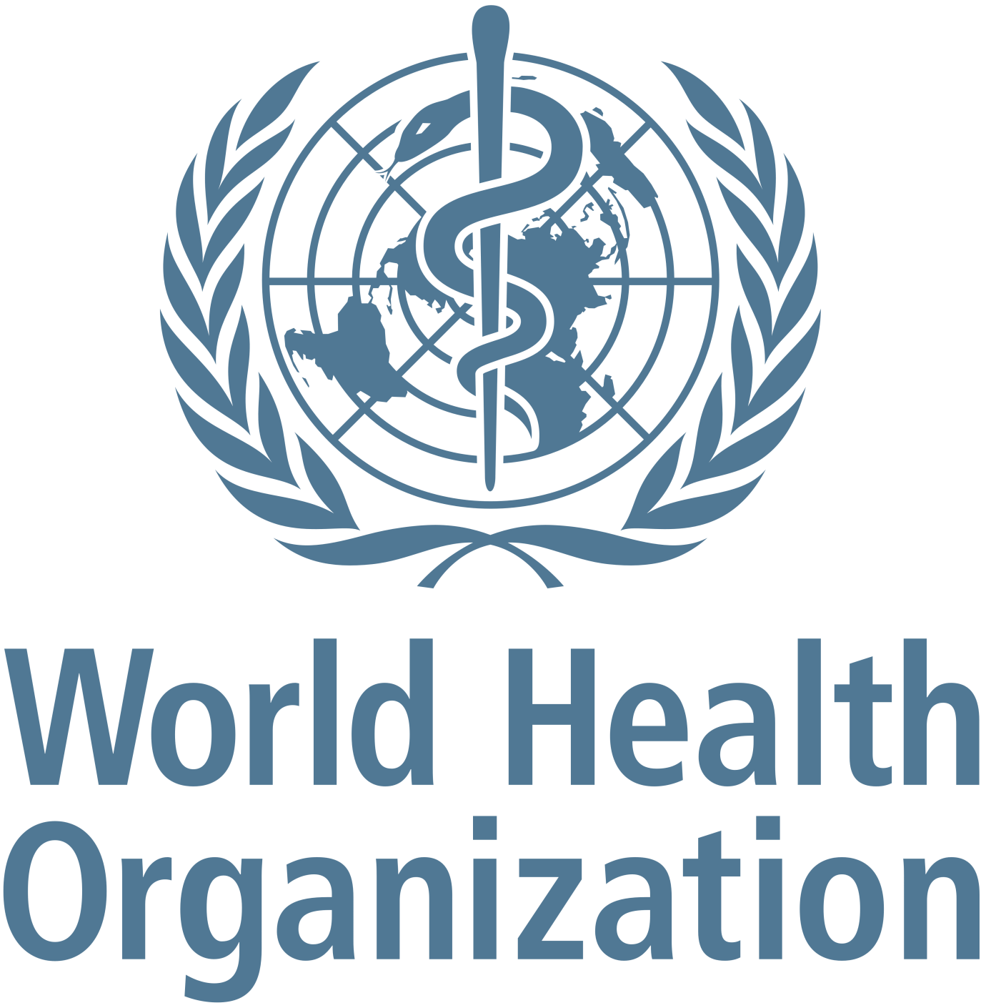
Study Guide
Antibiotics resistance as a threat to global health

Alexandra Janasová
Karolína Filičková
Content
Chairs letter 3
Introduction to the committee 4
Introduction to the topic 6
Definition of key words 7
Antibiotics resistance 8
Brief History of Resistance and Antibiotics 8
How bacteria become resistant? 9
Causes of antibiotics resistance 10
Consequences of antibiotics resistance 12
Involvement and actions taken so far 13
Possible solutions 15
Recommended reading and watching 17
Sources 17

Chairs letter

Dear delegates,
It is an utmost pleasure for us to welcome you to the World Health Organization committee of the Žilina Model United Nations 2019 conference! The organizing team has been working tirelessly to prepare the best possible experience for you, and we will do everything that is within our powers to do the same.
We are students of the Bilingual Grammar School in Žilina, which also happens to be the organizing school. Our passion for international relations has encouraged us to participate at various MUN conferences in countries such as Luxembourg, Poland, Sweden or Hungary. From our own experience we know that attending a MUN conference can be stressful experience, especially if it is your first time. Therefore, we have prepared this detailed study guide which will provide you a general overview of the issue.
During the sessions, we will be discussing one of the most significant threats to global health according to World Health Organization, being the antibiotics resistance. We hope that the debates will be as fruitful and successful for you as possible, and that you will find large amount of interesting information when doing your further research.
However, Zamun is not only about the formal discussion. It is unique opportunity to meet students from around the world, to make new friendships, to experience different cultures. Therefore, we wish you to get the most out of the conference and we are already looking forward to meeting you all.

Kind regards,
Alexandra Janasová (president of WHO) and Karolína Filičková (vice president of WHO)

Introduction to the committee

The World Health Organization (WHO) is the supervising and coordinating authority on global health within the UN. It aims to ensure that the UN development system operates effectively and efficiently to deliver on its mandate to support countries achieve better health and sustainable development.
Established in 1948 as a specialized UN agency, the WHO helps to tackle health challenges across the world. Article 1 of the WHO Constitution states that the objective of the WHO is "the attainment by all peoples of the highest possible level of health”, which is defined as “a state of complete physical, mental and social well-being and not merely the absence of disease or infirmity”. Therefore, the WHO promotes health as an integral part and outcome of the sustainable development agenda within the United Nations system and with other organizations and partners.
It is composed out of the Secretariat, an Executive Board consisting of 34 Members and its Member States and their workforce that is spread across regional offices and headquartered in Geneva, Switzerland.
The WHO supports the principle that all people should enjoy the highest standard of health, regardless of race, religion, political belief, economic or social condition. The role of WHO is crucial in the sphere of public health as it produces health guidelines and standards, supports countries in their public health issues as well as finances, promotes health research, provides leadership on matters critical to health and engages in partnerships where joint action is needed.
Moreover, the WHO is responsible for the World Health Reports (a series of worldwide World Health Surveys), which provide information for policymakers, donor agencies, international organizations and others to help them in deciding health policy and funding. The WHO also organizes the World Health Days: global health awareness days celebrated every year, which draw attention to important global health issues.
All these activities led and still lead to a lot of achievements the WHO can be proud of, as for example the increase of life expectancy, the defeat of smallpox, the distribution of life-saving treatment for HIV or elimination of measles or malaria in many countries.
However, the WHO does not content itself with these attainments, but continues its hard work to achieve the universal health coverage. Especially now, when the world has to face new health threats just as the increasing resistance of antibiotics, the WHO aims to protect their effectiveness through a global programme to fight antimicrobial resistance and to ensure that the entire world benefits.

Introduction to the topic

Antibiotics are medicines used to prevent and treat bacterial infections. They may either kill or inhibit the growth of bacteria. Since the discovery of first antibiotics, the treatment of bacterial infections has improved significantly. However, there are many factors such as growing number of infections or overuse and misuse of antibiotics, which are making them less effective and numerous bacterial types are becoming resistant to the treatment.
Today, antibiotic resistance is one of the biggest threats to global health, food security, and development. It can affect anyone, of any age, in any country. The emergence and spread of resistance is made worse when antibiotics can be bought for human or animal use without a prescription. Similarly, in countries without standard treatment guidelines, antibiotics are often over-prescribed by health workers and veterinarians and over-used by the public.
A longer duration of illness and treatment, longer hospital stays, higher medical costs and increased mortality are the impacts of antibiotics resistance. Additionally, antibiotic resistance is putting the achievements of modern medicine at risk. Organ transplantations, chemotherapy and surgeries such as caesarean sections become much more dangerous without effective antibiotics for the prevention and treatment of infections.
The delegates of World Health Organization will be trying to find an effective and sustainable solution to the antibiotics resistance and therefore combat one of the biggest threats to global health.

Definition of key words

Antibiotic
Is a drug used to treat bacterial infections by killing bacteria. Antibiotics have no effect on viral infections.
Antibiotic resistance
This term refers to a smaller effectivity of the antibiotic against the specific type of bacterium caused by an improved defence of bacteria towards the antibacterial medication. It´s usually caused by the overuse or misuse of the antibiotics.
Antimicrobial resistance
According to the WHO, antimicrobial resistance refers to broader categories of drug resistance that treats infections caused by other microbes as well as antibiotics, such as parasites (for example, malaria), viruses (for example, HIV) and fungi (for example, Candida).
Superbug
It is an informal term for a bacterium that has become resistant to antibiotics that usually are used to treat it, or any multidrug-resistant bacterium.

Antibiotics resistance

Brief History of Resistance and Antibiotics

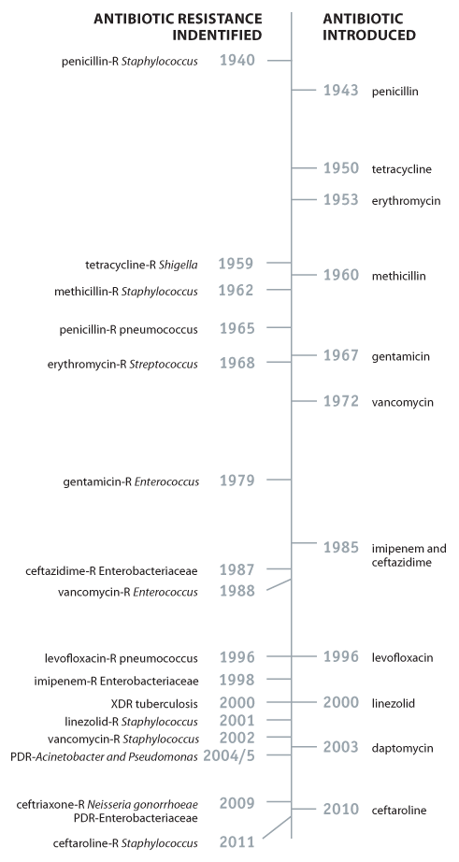
Penicillin, the first commercialized antibiotic, was discovered in 1928 by Alexander Fleming. Ever since, there has been discovery and acknowledgement of resistance alongside the discovery of new antibiotics. In fact, bacteria will always look for ways to survive and resist new drugs. More and more, germs are sharing their resistance with one another, making it harder for us to keep up.¹

How bacteria become resistant?
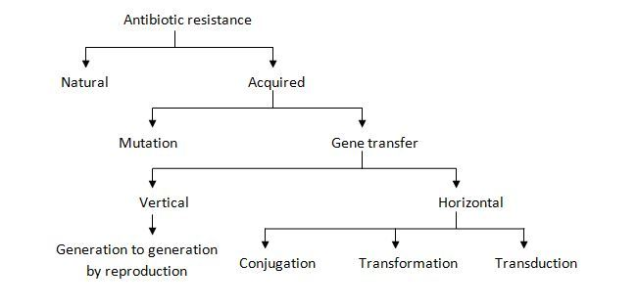
Natural resistance
Natural resistance occurs when a specific type of bacteria is resistant to certain type of antibiotics due to the construction of their cells. For example, antibiotics inhibiting cell wall synthesis are useless for Mycoplasma as these organisms lack cell wall.
Natural resistance to a certain antibiotic is not generally considered as antibiotic resistance because the bacteria were never susceptible to that antibiotic.
Acquired resistance
If the presence of antibiotics is unfavourable, bacteria either be suppressed or develop a resistance. If bacteria are not resistant to antibiotics naturally, they may gain resistant gene from other bacteria. Bacteria can gain resistance either by mutation or gene transfer from resistant bacteria.
Mutation is a stable heritable change of a gene of an organism. However, different types of mutation result in different forms of resistance. Resistant cells can be isolated from the cultures of bacteria that were susceptible to the antibiotic. This type of resistance is usually due to the mutation in chromosomal gene.
There is also a possibility that the resistant gene is transferred from one bacteria to another by reproduction (vertical gene transfer) or horizontally among the same species or even between different genus and species through conjugation, transformation and transduction (horizontal gene transfer).²

Causes of antibiotics resistance

- Over prescription of antibiotics
This is one of the most important and significant causes of antibiotics resistance. It is vitally important that we only use antibiotics when absolutely necessary. Antibiotics are not treating viral infections and they have no effect on them. However, they are often prescribed for this purpose. It is sometimes difficult to differentiate between viral and bacterial infections without costly tests. It is less time-consuming and more cost effective to proactively prescribe antibiotics, rather than take precautions and prescribe only the correct treatment.
- Incorrect use of antibiotics
This occurs when the duration of treatment is too short, if the doses is too low or the treatment is not complying with the right frequency. It can be weather the doctor who prescribes incorrect dosage of antibiotics or a patient not respecting the conditions of treatment. This leads to the fact that not enough antibiotic is present in the body and so the bacteria will survive and may become resistant.
- Extensive agricultural use
The issue is also an extensive usage of antibiotics as growth supplements in livestock, in both developing and developed countries. For example, an estimated 80% of antibiotics sold in the U.S. are used in animals, primarily to promote growth and to prevent infection. Subsequently, the antibiotics used in livestock are ingested by humans when consuming food. Recent molecular detection methods are demonstrating that resistant bacteria reach consumers through meat products. Even though since 2006 free usage of antibiotics for growth promotion purposes in livestock has been banned in the European Union, still this is a problem affecting numerous countries around the world. ³
- Poor hygiene and sanitation
Although, there have been measures taken in recent years to improve and develop hygiene policies and practices in hospitals (for example, sanitising gel dispensers), practices are not always followed and enforced as rigorously as they need to be. Also, the hygiene standard are usually higher in developed countries, therefore, we should focus mainly on developing countries. Not only hygiene in hospitals, but also personal hygiene must be improved significantly. It may seem obvious for you, but practices such as washing hands or taking shower regularly are still not followed by surprising amount of people in developing countries. Inadequate wash standards can lead to the spread of pathogens through unsafe water resulting in gastrointestinal disease, increasing even further the need for antibiotic treatment.⁴
- Availability of Few New Antibiotics
The development of new antibiotics by the pharmaceutical industry, a strategy that had been effective at combating resistant bacteria in the past, had essentially stalled due to economic and regulatory obstacles. The research of new antibiotics is extremely expensive and large amount of artificially created antibiotics fail in safety and efficacy testing. Bearing in mind the fact that antibiotics are gradually becoming less effective, it is much more lucrative to develop drugs such as antidepressants, statins or anti-inflammatory medications, as they can be used regularly without losing effectiveness. ⁵

Consequences of antibiotics resistance

Antibiotic resistance is rising to dangerously high levels in all parts of the world. New resistance mechanisms are emerging and spreading globally, threatening our ability to treat common infectious diseases. The list of infections is still growing. Pneumonia, tuberculosis, blood poisoning, gonorrhoea, and foodborne diseases are becoming harder, and sometimes even impossible to treat as antibiotics become less effective.
The further antibiotic resistance spreads, the more often common antibiotics—including many available as generics—must be retired. This means that ridding patients of infection requires longer, more expensive forms of therapy.
Additionally, various medical techniques which are common and frequent today may become a high risk without antibiotics working properly. For example, there is a high dependence of surgery on the administration of antibiotics before and after the operation. Patients who have undergone a cancer treatment rely on antibiotics to protect them from bacteria, as their immune systems are compromised. Furthermore, patients with organ transplants need antibiotics to suppress their immune systems from attacking the transplanted organs.
The cost of all these mentioned health procedures would dramatically increase without effective antibiotics. The effect would be lower availability of healthcare as well as need of governments to allocate larger amount of finance to healthcare.
These are groups of people at an increased risk of experiencing the antibiotic resistance:
- infants, especially premature babies, as they may not have strong immune systems;
- seniors, particularly those living in long-term care facilities or seniors' residences, as they are in close contact with others and may have wakened immune system due to illness or extended antibiotic use
- people who are homeless or living in crowded or unhygienic conditions where it is easy to contract infections
- people with weakened immune systems due to illness or injury⁶

Involvement and actions taken so far

World health organization
Tackling antibiotic resistance is a high priority for WHO. A global action plan on antimicrobial resistance, including antibiotic resistance, was endorsed at the World Health Assembly in May 2015. The global action plan aims to ensure prevention and treatment of infectious diseases with safe and effective medicines.
The “Global action plan on antimicrobial resistance” has 5 strategic objectives:
- To improve awareness and understanding of antimicrobial resistance.
- To strengthen surveillance and research.
- To reduce the incidence of infection.
- To optimize the use of antimicrobial medicines.
- To ensure sustainable investment in countering antimicrobial resistance.
WHO has many other initiatives to decrease antibiotics resistance, including World Antibiotic Awareness Week, The Global Antimicrobial Resistance Surveillance System (GLASS), Global Antibiotic Research and Development Partnership (GARDP) and Interagency Coordination Group on Antimicrobial Resistance (IACG).⁷
United States of America
There has been established The National Action Plan for Combating Antibiotic-resistant Bacteria which provides a roadmap to guide the Nation in rising to this challenge. By 2020, implementation of the National Action Plan will lead to major reductions in the incidence of urgent and serious threats. This plan will also result in improved antibiotic stewardship in healthcare settings, prevention of the spread of drug-resistant threats, elimination of the use of medically-important antibiotics for growth promotion in food animals, and expanded surveillance for drug-resistant bacteria in humans and animals, as well as creation of a regional public health laboratory network aiming on research and development.⁸

India
India is country with one of the highest risks that the antibiotics will not work anymore. Many Indian doctors prescribe antibiotics for the simplest of infections. Poor infection control strategies, inadequate sanitary conditions and inappropriate food-handling also promote the spread of antibiotic resistance. The Government of India has taken a series of initiatives to tackle the growing problem of resistance. These include a National Task Force on AMR Containment constituted in 2010, the national policy on AMR containment in 2011 and some other action plans.⁹
Sweden
Sweden has relatively low use of antibiotics per capita and a comparatively favourable situation with regard to antibiotic resistance. The antibiotic consumption in Sweden has decreased substantially since the mid-1990s. Strama (the Swedish strategic programme against antibiotic resistance), initiated in 1995, plays a central role in this field and is now an advisory body to the Public Health Agency of Sweden. Political support and commitment for the work is strong and many stakeholders are involved on local and national level. This results in the fact that Sweden is country with very good results concerning the fight against antibiotics resistance.¹⁰

Possible solutions

There are many strategies and steps that can be taken at all levels of society to reduce the impact and limit the spread of antibiotic resistance. The delegates shall consider all the causes of the discussing issue and try to find a suitable solution for all the countries, as the antibiotic resistance is a global problem, requiring efforts from all nations and many sectors.
- The correct prescription of antibiotics
Encourage antibiotics to be prescribed only in cases where necessary. This could reduce the problem of antibiotic overuse and misprescription, however, it may bring up problems if antibiotics are not prescribed when they should have been.
- Providing countries with better and more diverse access to healthcare
As the antibiotics are cheap and easy to import, in many countries, especially developing ones, they are used as the only treatment. The WHO could provide these countries with new medications and alternative solutions and thus limit the overuse of antibiotics.
- Reduction of the antibiotic usage in the agricultural sector
By restricting the usage of antibiotics for growth promotion or as a prevention of diseases in healthy animals we could limit the growth of antimicrobial resistant microorganisms. But attention, the decrease in the growth rates of animals and the impact on the agricultural industry should also be considered.
- Invest in research and development
Further development of new antibiotic medications and vaccines can help to combat the bacteria that are now becoming resistant to the already-existing drugs. The recent studies also show a new possible way to stop bacterial infections by affecting the bacterial genetics. This solution requires a large investment to be put into the research, but it could open up a vital new way of treatment.

- Promotion of the public awareness
Civil society plays a crucial role in translating adopted policies into the real change, therefore it´s recommended to tackle the issue also through awareness raising on several levels:
- The causes of antibiotics resistance
- The threat related to the overuse of antibiotics and antibiotic resistance
- The correct usage of antibiotics
- Encouragement of people to choose foods produced without the use of antibiotics
- Ways of infection prevention

Recommended reading and watching

https://www.youtube.com/watch?v=znnp-Ivj2ek
https://www.youtube.com/watch?v=HN5ultN7JaM
https://www.youtube.com/watch?v=-ZX97bIbZBQ
https://www.healthline.com/health/antibiotics/why-pipeline-running-dry
https://ourworldindata.org/antibiotic-resistance-from-livestock
https://ec.europa.eu/health/amr/antimicrobial-resistance_en
https://www.cdc.gov/antibiotic-use/index.html?fbclid=IwAR0YqcseaaQQamZDLF7sJIhvtrINcMCMeGU2dXKH8i21_qvQ1UEiKb1hn0M
https://resistancemap.cddep.org/?fbclid=IwAR0JzN0IXpreyvp3RXYbwH2axpamSy706RBZAQAWvaRon5coygFwZFVS95s

Sources

¹ About Antimicrobial Resistance; https://www.cdc.gov/drugresistance/about.html
²Antibiotic Resistance: Origin, Causes, Mechanism and Prevention; https://microbeonline.com/antibiotic-resistance-origin-causes-mechanism/
³ The Antibiotic Resistance Crisis; https://www.ncbi.nlm.nih.gov/pmc/articles/PMC4378521/
⁴ Causes of Antibiotic Resistance; https://www.antibioticresearch.org.uk/causes-antibiotic-resistance/
⁵ 6 Factors That Have Caused Antibiotic Resistance; https://infectioncontrol.tips/2015/11/18/6-factors-that-have-caused-antibiotic-resistance/
⁶Antibiotic resistance and risks to human health; https://www.canada.ca/en/public-health/services/antibiotic-antimicrobial-resistance/impacts-antibiotic-resistance.html
⁷Antibiotic resistance; https://www.who.int/news-room/fact-sheets/detail/antibiotic-resistance
⁸ National Action Plan For Combating Antibiotic-resistant Bacteria; https://www.cdc.gov/drugresistance/pdf/national_action_plan_for_combating_antibotic-resistant_bacteria.pdf
⁹ All About Antibiotic Resistance: Is India Heading To The Point Where No Drugs Will Work?;https://thelogicalindian.com/awareness/antibiotic-resistance/
¹⁰ Swedish work on containment of antibiotic resistance;https://www.folkhalsomyndigheten.se/the-public-health-agency-of-sweden/communicable-disease-control/antibiotics-and-antimicrobial-resistance/swedish-work-on-containment-of-antibiotic-resistance/
Working for better health; https://www.who.int/about/what-we-do/who-brochure/
High levels of antibiotic resistance found worldwide, new data shows; https://www.who.int/mediacentre/news/releases/2018/antibiotic-resistance-found/en/

