UNITED NATIONS FIRST COMMITTEE

Topic: INTERNATIONAL INTERVENTION IN CIVIL WARS

Letter from the Chair
Honourable delegates,
Before the conference starts, there is still some work to be done. While the organisation team is doing its best to organize spaces; workshops, catering and so on, one important thing has to be done by you.
You are the ones that fill the conference with life, the ones that lead interesting discussions and fruitful debates and make innovative resolutions reality. This requires some preparation on your side.
In advance of the conference, I expect all delegates to research their state’s and become experts for the given agenda topics, to familiarize themselves with the rules of procedure and to practice their debating and writing skills. Here are some useful hints on how to get prepared for the ZAMUN conference.
- Do some research
The first step will be to do some research in order to prepare for the conference. You should look into these areas:
• Structure and history of the United Nations
• Your assigned member state
• Committee
• Your role in the committee
• Your agenda topics
These questions should guide your research:
• What are the key issues of my agenda topics?
• Why are these issues important?
• What are possible solutions?
• What is hindering these solutions?
• Which states share your view of the given issue?
• Which states are opposed to your position?
• What has the UN or other international agencies done so far, in order to solve these issues?

- Write a position paper
An important task for you before the conference starts is to write a position paper (policy statement).
A proper Policy statement should be about 90 seconds in length and should give you the opportunity to tell those in the committee what you and your country plan to do at the conference and the outcomes you would like to see. Writing a policy statement is very important, since it helps you during the entire conference as a starting point of discussion.
A Policy Statement should be very similar (in terms of content) to a Resolution's Preambulatory Clauses. Each topic should be addressed briefly in a succinct policy statement representing the relevant views of your assigned country.
Please send your position papers to your committee email address (tmichakovadisec@gmail.com).

- Familiarize yourself with the rules of procedure
In order to participate effectively in your committee you need to familiarize with the rules of procedure before the conference. You should carefully read the rules of procedure as well as with the explanations about the flow of the debate
If any of the rules remains unclear to you, please, contact me on my email address (tmichalkovadisec@gmail.com).
4. Practice your speaking and debating skills
Being a delegate at a MUN conference requires speaking and debating skills. Even the best research goes wasted if you cannot convince other delegates of your standpoint and ideas. In advance of the conference you should prepare opening speeches for each topic and practice them at home, in order to get to a good start at the conference
5. Writing a resolution
The main goal of the committee sessions will be to find common solutions to the gives topics. These will be captured in a resolution; therefore, it is important that you are familiar with the formal standards of a resolution.
Please read the section on how to write a resolution very attentively.
I also suggest reading some original UN resolutions to get confident with the formal language, style and structure of a proper and good resolution.

Tereza Michalková, Chair of DISEC committee

Introduction
Civil wars have unfortunately become routine rather than exceptional events in the last few decades, with various epochal changes like the growing consensus towards democracy as the political regime of choice, and the opening up of economies worldwide under the reigning capitalist system being recent suspects, besides time-worn concerns like ethnicity and religion still playing their part.
What is a civil war?
A civil war is a war between organized groups within the same state or republic, or, less commonly, between two countries created from a formerly united state. It is a high-intensity conflict, often involving regular armed forces, that is sustained, organized and large-scale.
Causes of civil wars
Civil wars are distinguished from civil conflicts on various grounds, most importantly the significantly larger casualty count, and are characterized by armed struggle between participants, one of whom must be a recognized administration. The instigators, more often than not, are armed groups with extensive organizational structures and grievances against the state on grounds pertaining to ethnicity, religion, inequality of standards, absence of voice and representation, rampant unemployment etc.
The 100 deadliest civil wars and armed conflicts since the Second World War
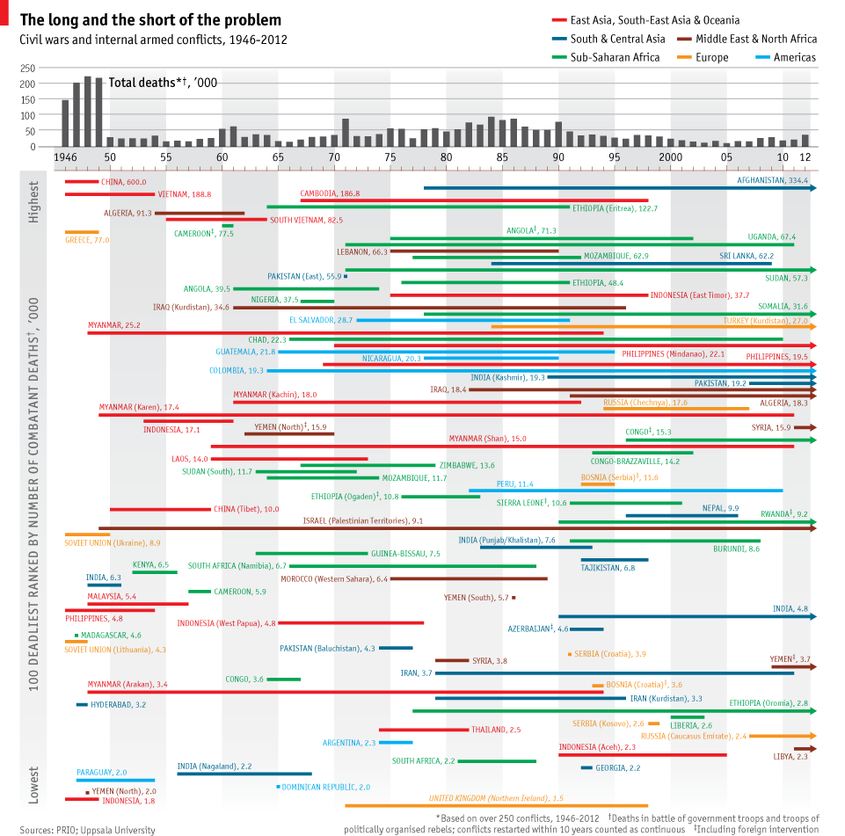
(http://media.economist.com/sites/default/files/media/2013InfoG/databank/CivilWars.png)

Consequences and settlement possibilities
Intervention in civil conflicts is one of the most vexing decisions facing modern great powers -- Bosnia, Kosovo, Somalia, and Haiti being merely the most recent examples.
The most obvious and sickening by product of a civil war is the often excessive violence and destruction. The violence has been partially explained by its psychological impact on citizens, and destruction by its impact on opportunities for citizens, both of which either directly or indirectly motivate recruitment and force complicity.
Closing remarks
Dear delegates,
I hope this study guide provides you with a sufficient base for your research of the subject. However, I strongly advise you to do your own research, since study guides only provide a small introduction into the mater. If convenient, contacting embassies of your countries can also be somewhat beneficial. Please remember that study guides aim to be unbiased, and your countries might have somewhat different views on some points.
Nevertheless, on the behalf of the whole ZAMUN DISEC organizing team, I would like to express the joy of the vision of meeting you all. Hope you have a lovely experience and fruitful debates.

Sample Position Paper

Delegation: Brazil
Committee: Disarmament Committee
Issue: Measures to prevent terrorists from acquiring weapons of mass destruction

Brazil fervently supports measures to support the Weapons of Mass Destruction Branch of the UN Office for Disarmament Affairs in its attempts to prevent terrorists from acquiring weapons of mass destruction (WMD), as it firmly believes such efforts are necessary to combat the global threat of terrorism.
Brazil endorses the Outcome Document of the 2005 World Summit, adopted 13 September 2005, which condemns terrorism in all its forms and manifestations and strives to set up an international system that strictly monitors the transfer of materials that may be used to produce WMD. Brazil, one of the driving forces behind the 1967 Treaty of Tlatelolco, which turned Latin America into the world’s first nuclear-free zone, applauds the recent efforts made by the Members of the United Nations to free the world of any type of WMD.
We feel especially responsible as our nation commands huge uranium resources. We view with satisfaction the recent efforts of Member States to prevent the use of WMD by terrorists. However, Brazil expresses its deepest regret that, in spite of recent efforts to combat the acquisition of WMD by terrorist groups, some countries have refused to abide by the will of the international community. It is our deepest interest to ensure a world untroubled by the transfer of WMD and materials that can be used in the production of any such weapons.

Preambulatory Phrases
Affirming
Alarmed by
Approving
Aware of
Bearing in mind
Believing
Cognizant of
Confident
Contemplating
Convinced
Declaring
Deeply concerned
Deeply conscious
Deeply convinced
Deeply disturbed
Deeply regretting
Desiring
Emphasizing
Expecting
Expressing its appreciation
Expressing its satisfaction
Fulfilling
Fully alarmed
Fully aware
Fully believing
Guided by
Having adopted
Having considered
Having considered further
Having devoted attention
Having examined
Having heard
Having received
Having studied
Keeping in mind
Noting further
Noting with approval
Noting with deep concern
Noting with regret
Noting with satisfaction
Observing
Reaffirming
Realizing
Recalling
Recognizing
Referring
Seeking
Taking into account
Taking note
Viewing with appreciation
Welcoming

Operative Clauses

Accepts
Affirms
Approves
Authorizes
Calls for
Calls upon
Condemns (SC only)
Confirms
Congratulates
Considers
Declares accordingly
Demands (SC only)
Deplores
Designates
Draws attention
Emphasizes
Encourages
Endorses
Expresses its appreciation
Expresses its hope
Further invites
Further proclaims
Further recommends
Further reminds
Further requests
Further resolves
Has resolved
Notes
Proclaims
Reaffirms
Recommends
Regrets
Reminds
Requests
Resolves
Solemnly affirms
Strongly condemns
Supports
Takes note of
Trusts
Urges
Welcomes

Further reading:
(Please note that these sources also include all sources used to write the study guide)
http://www.dnaindia.com/analysis/standpoint-civil-conflicts-and-wars-the-pity-of-it-all-1963675
http://www.economist.com/content/inner-turmoil
http://prijipati.library.usyd.edu.au/bitstream/2123/4987/1/Foreign%20Intervention%20and%20Warfare%20in%20Civil%20Wars.pdf
http://www.foreignaffairs.com/articles/56121/g-john-ikenberry/civil-wars-and-foreign-powers-outside-intervention-in-intrastate
http://ir.uiowa.edu/cgi/viewcontent.cgi?article=3484&context=etd
http://ussc.edu.au/ussc/assets/media/docs/publications/Foreign-Intervention-and-Warfare-in-Civil-Wars.pdf
http://www.foreignaffairs.com/articles/40236/llyod-n-cutler/the-right-to-intervene
http://politics.as.nyu.edu/docs/IO/5628/kelly_siegel.pdf

Recently in media:
http://www.dailytimes.com.pk/foreign/22-Mar-2014/syria-asylum-claims-in-rich-nations-more-than-double-in-2013-un
http://www.theguardian.com/world/2014/mar/16/colombia-brink-ending-civil-war-farc
http://www.huffingtonpost.com/2014/03/15/syria-war-children_n_4967063.html
http://gulfnews.com/opinions/columnists/civil-war-as-in-syria-can-ignite-cold-war-1.1301521
http://www.independent.co.uk/news/world/middle-east/syrias-road-to-hell-a-hairraising-journey-between-damascus-and-tartous-9172003.html
http://www.nation.com.pk/international/04-Mar-2014/fighting-in-damascus-halts-aid-to-palestinians-un
http://www.nydailynews.com/news/world/calls-syria-humanitarian-aid-article-1.1702816
http://edition.cnn.com/2014/02/15/world/meast/syria-civil-war/
http://www.nytimes.com/2014/02/06/opinion/courts-cant-end-civil-wars.html?_r=0
http://www.washingtonpost.com/blogs/worldviews/wp/2014/02/12/this-map-of-syria-shows-why-the-war-will-be-so-difficult-to-end/

